Chapter-14 Part-4

Aplia Homework: The Case for Free Markets: The Price System

**1. Efficiency, inefficiency, and equity**

Darnell and Eleanor are 13-year-old twins who are fighting over how to spend a $200 gift certificate they jointly won in a raffle. The gift certificate is for a store that sells MP3 players. There are three kinds of MP3 players available: one that costs $150, one that costs $100, and one that costs $50. Each twin wants his or her own MP3 player. Both twins greatly prefer the $100 player to the $50 player, but they only slightly prefer the $150 player to the $100 player. The gift certificate can be used only once, regardless of whether or not the full $200 value is redeemed.

Suppose their mother intervenes and uses the gift certificate to purchase each twin the $100 player. This outcome is ____________ because _____________________.

**2. Public interest and price changes**

When the price of a good increases, it undoubtedly hurts individual consumers, since they now have to pay more for a particular good. However, there are some cases in which a price increase can actually serve the public interest.

Which of the following is an example of a price increase that serves the public interest? Check all that apply.

A monopolist sets its price above that which would occur in a perfectly competitive market.

The price for a hunting license is increased in an effort to reduce the number of hunters.

Airport officials charge higher fees for peak-hour landings in order to reduce congestion in the local airspace and terminal.

**3. Economic decisions in a market economy**

One of the three basic coordination tasks an economy has to face is ________.

A free-market system answers the preceding question by _________.

**4. Consumer’s surplus and price changes**

The following graph shows the demand curve for a group of students in the market for graphing calculators. Each student wants only one calculator. Assume that if what an individual has a willingness to pay equals the market price, he or she will make the purchase.

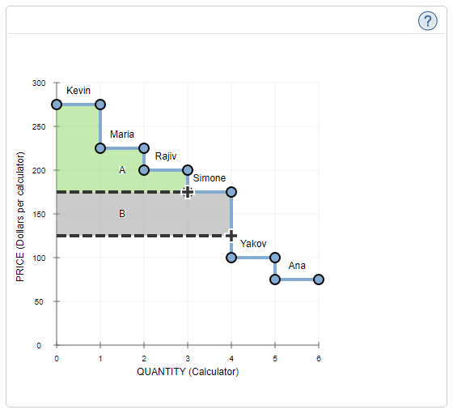

Region A (the green shaded area) represents total consumer's surplus when the market price is _______, while Region B (the grey shaded area) represents _________ when the market price _____________.

Complete the following table by indicating which statements are true or false based on the information provided on the previous graph.

| **Statement** | **True** | **False** |
| --- | --- | --- |
| Consumer's surplus is larger when the price is $125 than when it is $175. | _____ | _____ |  |
| There are more students buying used calculators when the market price is $125 than when it is $175. | _____ | _____ |  |
| Assuming each student receives a positive surplus, Kevin will always receive less consumer's surplus than Maria. | _____ | _____ |  |

In order for Ana to earn consumer's surplus of exactly $50 from buying a graphing calculator, the market price needs to be _____.

**5. Producer's surplus and price changes**

The following graph shows the supply curve for a group of students looking to sell used economics textbooks. Each student has only one used textbook to sell. Each rectangular segment under the supply curve represents the acceptable minimum price, for one student. Assume that anyone who has an acceptable minimum price equal to the market price is willing to sell his or her used textbook.

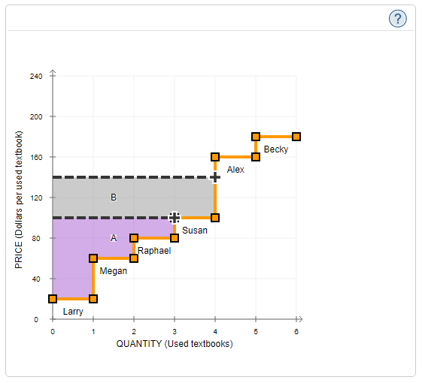

Region A (the purple shaded area) represents the total producer's surplus when the market price is _______, while Region B (the grey shaded area) represents _______ when the market price _______.

Complete the following table by indicating which statements are true or false based on the information provided on the previous graph.

| **Statement** | **True** | **False** |
| --- | --- | --- |
| Assuming each student receives a positive surplus, Raphael will always receive more producer's surplus than Susan. | _____ | _____ |  |
| Producer's surplus is smaller when the price is $140 than when it is $100. | _____ | _____ |  |
| There are fewer people selling used textbooks when the market price is $140 than when it is $100. | _____ | _____ |  |

In order for Becky to earn a producer's surplus of exactly $60 from selling a used textbook, the market price needs to be _______.

**6. Maximizing consumer and producer surplus**

The following table shows the value of taking a karate lesson for five students, and the opportunity cost of teaching a karate lesson for five instructors. Each instructor can teach only one student, and each student can take only one lesson.

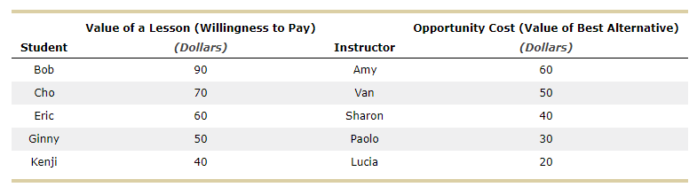

If prices are negotiated directly between instructor and student, it is _______ for all five students to have lessons, and for all students and all instructors to be better off than they would have been otherwise. In this case, the total net benefit (sum of both consumer and producer surplus) must be _______.

On the following graph, use the blue points (circle symbol) to plot the demand for karate lessons. Then, using the orange points (square symbol), plot the supply of karate lessons.

Hint: Plot each curve as a step function, so that the total number of people willing to buy or sell lessons at each price is shown accurately. The first point on your demand curve should be (0, $90), while the second point should be (1, $90). The last point on the demand curve should be (5, $0). Similarly, the first point on your supply curve should be (0, $20), while the second point should be (1, $20). The last point on the supply curve should be (5, $100).

If there is one price in this market, and it is set by supply and demand, that price will be _____, and total surplus (consumer and producer surplus combined) will be _____.

Suppose a price floor of $65 is enacted in this market.

Which of the following mutually beneficial (that is, beneficial to both the buyer and the seller) trades that occurs before the price floor is imposed would not occur afterward?

Paolo gives Cho a karate lesson.

Van gives Eric a karate lesson.

Amy gives Kenji a karate lesson.

Sharon gives Bob a karate lesson.

Based on the preceding parts of this question, you can conclude that having a single, market-determined price results in which of the following? Check all that apply.

The highest possible total surplus

An efficient allocation of resources

Production of as much of the good as the economy can possibly produce

Some consumers going without a good, even though it would be possible for every consumer to buy the good and still ensure that all consumers and producers have positive surplus

**7. Why is perfect competition efficient?**

True or False: A central planner is not needed for a perfectly competitive market to achieve efficiency.

True

False

**8. Marginal analysis and efficiency**

The following graph shows the market demand and supply curves for pairs of socks that are sold in a perfectly competitive market.

Use the graph input tool to help you answer the following questions. You will not be graded on any changes you make to this graph*.*

**Note**: Once you enter a value in a white field, the graph and any corresponding amounts in each grey field will change accordingly.

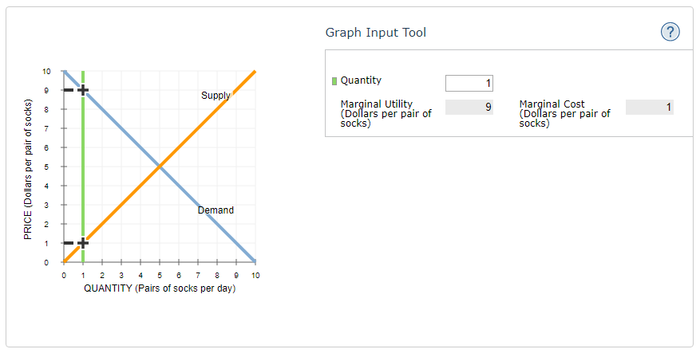

If the economy produces and sells six pairs of socks (represented by the green line on the graph), the marginal utility (MU) of the last pair of socks bought is ______, and the marginal cost (MC) of the last pair of socks sold is ______. This means that the MU of the last pair of socks bought is _______ the MC of the last pair of socks sold, so the market is _______.

**9. The price system and efficiency**

It has been demonstrated that a competitive market economy allocates resources efficiently. Specifically, in a competitive equilibrium, all opportunities for additional gain have been exhausted so that no individual can be made better off without making another individual worse off. Economists often argue that economic efficiency can be improved if prices that are set by non-market forces are set so that higher prices are charged for relatively overutilized resources.

Which of the following is an example of how a price system can be manipulated to promote efficiency?

Price supports can be used to make sure domestic barley producers stay in business.

A price ceiling can be imposed on the market for electricity so that everyone can afford electric power.

The price of electricity can be increased during peak demand periods to reduce strain on the system.

United Airlines can charge one price for a flight to and from anywhere in the United States, regardless of the actual cost.